Olitech EasyMate 2

Type of device: Mobile
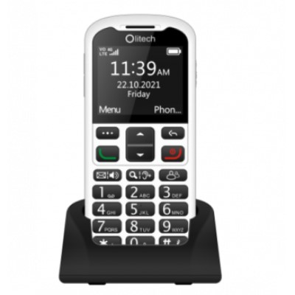

Actual Display Size : 2.2 inches
Button Type : Physical Keypad
Network Capability : 3G,4G
Year of Release : 2022
Average Price : $179 as of 18 08 2022

Accessibility Features:

Cognitive
- GPS
- Photo Telephone List
- Screen Timeout Disabled
- Simple Instructions
- Simple Reminders
Simplify Display

Hearing Impairment and Deaf
- Bluetooth or Wi-Fi
- Hearing Aid Microphone Coupling
- Hearing Aid Telecoil Coupling
- Text Messaging/SMS
- Vibrating Alerts - Adjustable
Visual Alerts - Incoming Calls

Vision
- Battery Alert - Audible
- Bluetooth or Wi-Fi
- Brightness Adjustable
- High Contrast Mode
- Key Marker – Raised '5'
- Key Numbers - Standard Layout
- Text Style Adjustable
Voiced Menus

Speech
- Bluetooth or Wi-Fi
- Messaging Options - MMS
Predictive Text

Physical
- Bluetooth or Wi-Fi
- Headset - plug connected
- Lanyard Option
- Physical Dialling Keys
Speaker-phone option

How and where to get it from?
You can buy this phone from Vision Australia, Olitech, and other retailers.

More information is available on:
Olitech EasyMate 2 PDF User Manual Website
Olitech EasyMate 2 Instructional Videos Website

